***Welcome to Leafield Athletic Football Club***

[](https://www.google.co.uk/imgres?imgurl=http://img.mstatic.co/team_profile_pictures/12949/large_original_ratio/5068.jpg?1392772912&imgrefurl=http://mitoo.co/clubs/leafield-athletic-fc&docid=Xz99x_Rj4Yw2FM&tbnid=g8sGwcvIT7AAcM:&w=300&h=295&ei=Odt1VJWXMdLlaISFgbgF&ved=0CAIQxiAwAA&iact=c)

“Second to None”

Club Information Pack for Parents and Guardians

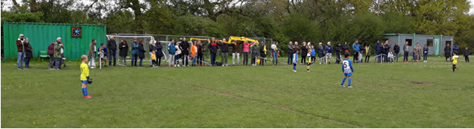

**Our Grounds**

Our U7 to U12 Teams are based at Tythe Barn Lane, B90 1PH

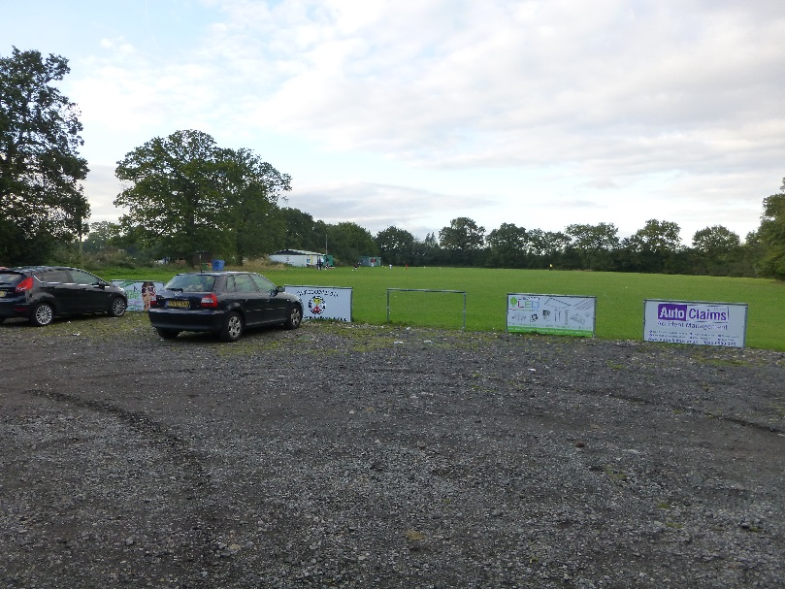

Our U13 to U18 Teams together with our Adults and Over 35s (Vets) Teams are based at Rumbush Lane, B94 5NA

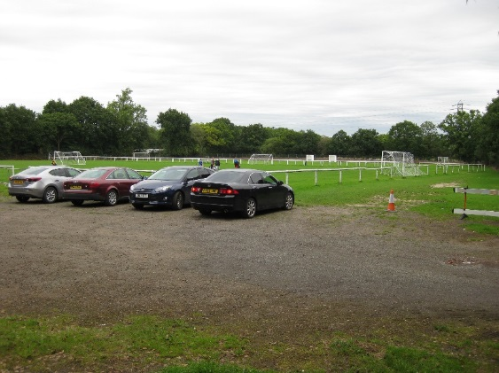 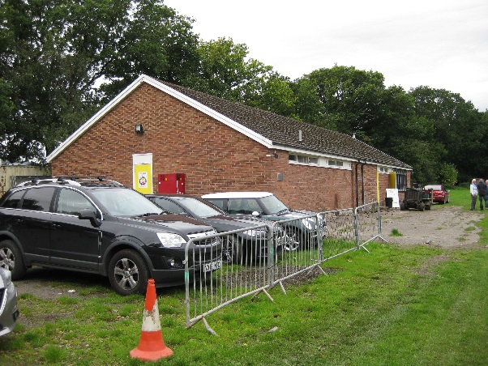

There is car parking available at both of our grounds although at peak times these do become very full. We ask that all parents, guardians and other spectators park considerately to ensure access is possible to and from the ground and that access it available to emergency vehicles if required.

**OUR CLUB**

Leafield Athletic Football Club was formed in 1970 and is one of the oldest Clubs in the local area. As such the Club is very proud to have helped so many kids to enjoy playing football and continue to do so.

Our junior teams play in the Central Warwickshire Youth Football League which was founded in 1969 to support minor and youth teams, U7-U18 teams.

None of our teams would exist without the people who take on the roles of Club Officers, Managers, Coaches, First Aiders, Team Secretaries and Treasurers and of course not forgetting those Parents/ Guardians who bring the children to training and matches throughout the season. Leafield Athletic thank you all for making Leafield Athletic FC the great Club that it is.

Finally, a warm welcome to all our new teams this season, LAFC wish you and your players a great footballing season.

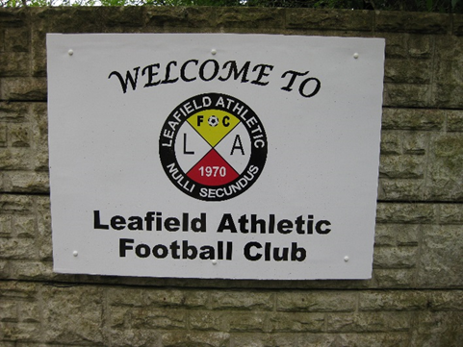

**Club Contacts**

|  |  |  |
| --- | --- | --- |
| **Chairman** | **Darren Swann** | **07971 566004** |
|  |  |  |
| **Vice Chairman** | **Steve Clarke** | **07772 732069** |
|  |  |  |
| **Secretary** | **Nigel Livingstone** | **07900 497940** |
|  |  |  |
| **Treasurer** | **Nigel Livingstone** | **07900 497940** |
|  |  |  |
| **Child Welfare Officer** | **Jarrod Marsland/Nigel Livingstone** | **07905 484622/07900 497940** |
|  |  |  |
| **Clubhouse Manager/Groundsman** | **Richard Pittaway** | **07732 875597** |

**Our Code of Conduct for Parents & Guardians**

Parents & Guardians have a great influence on children’s enjoyment and success in football.  All children play football because they first and foremost love the game – it’s fun.

It is important to remember that however good a child becomes at football within their team LAFC believe that Parents/Guardian’s positive encouragement will contribute to:

***Children enjoying football; A sense of personal enjoyment; Self-esteem; Improving the child’s skills and techniques.***

A Parent or Guardian’s expectations and attitudes have a significant bearing on a child’s attitude towards:

***Other players; Match Officials; Managers; Spectators.***

LAFC look to Parents/Guardians to always be positive and encouraging towards all of the children participating not just their own.

LAFC looks to Parents & Guardians to set a positive example by:

* ***Applauding the opposition as well as your own team.***
* ***Avoiding coaching any child during matches.***
* ***Not engaging in, or tolerating offensive, insulting or abusive language or behaviour.***
* ***Always respecting coach’s and referee’s decisions.***
* ***Giving attention to each of the children involved in football not just the most talented.***
* ***Giving encouragement to players participating in football matches or training.***
* ***Respecting the club’s facilities (i.e. ensuring equipment is respected, ensuring litter it put into bins etc)***

**N.B.** *LAFC reserve the right to ask a Parent/Guardian to leave the ground if requested to do so by a Club Official if they believe the above Code of Conduct has been disregarded.*

**Player: Medical Information, Registration Fee and Team Fees**

*The Parent or Guardian agrees to provide information on any medical conditions for player that they believe the team manager/coach should be aware of while playing for team.*

The Parent or Guardian agrees to pay the Registration Fee and Team Fees requested by Team Manager or LAFC for the 2022/2023 season.

**Player Fines**

The Parent or Guardian agrees to pay LAFC for fines incurred by their child from LAFC, the Birmingham FA, Central Warwickshire Youth Football League or Midland Football League within 2 weeks of request by LAFC or their child’s Team Manager.

***As a Parent/Guardian of a Player for a Leafield Athletic FC Team, I confirm acceptance of the above LAFC Rules for Parents & Guardians.***

**Team**: **Leafield Athletic Under …………………….**

**Player Name:**

.............................................................................................

(Print Name)

**Parent/Guardian Name**:

…………………………………………………………………………………………

(Print Name)

**Parent/Guardian Signature**:

…………………………………………………………………………………………

**Return signed form to LAFC Team Manager (scan copy or photograph copy will suffice). LAFC will not/review the registration of a player without a signed form being received from the Parent or Guardian of that player.**